Exercise 1 – Northwind Queries

1. Write a query that lists all Customers in either Paris or London. Include Customer ID, Company Name and all address fields.

SELECT CustomerID, CompanyName, Address, City, Region, PostalCode

FROM Customers

WHERE city = 'london' or city ='paris'

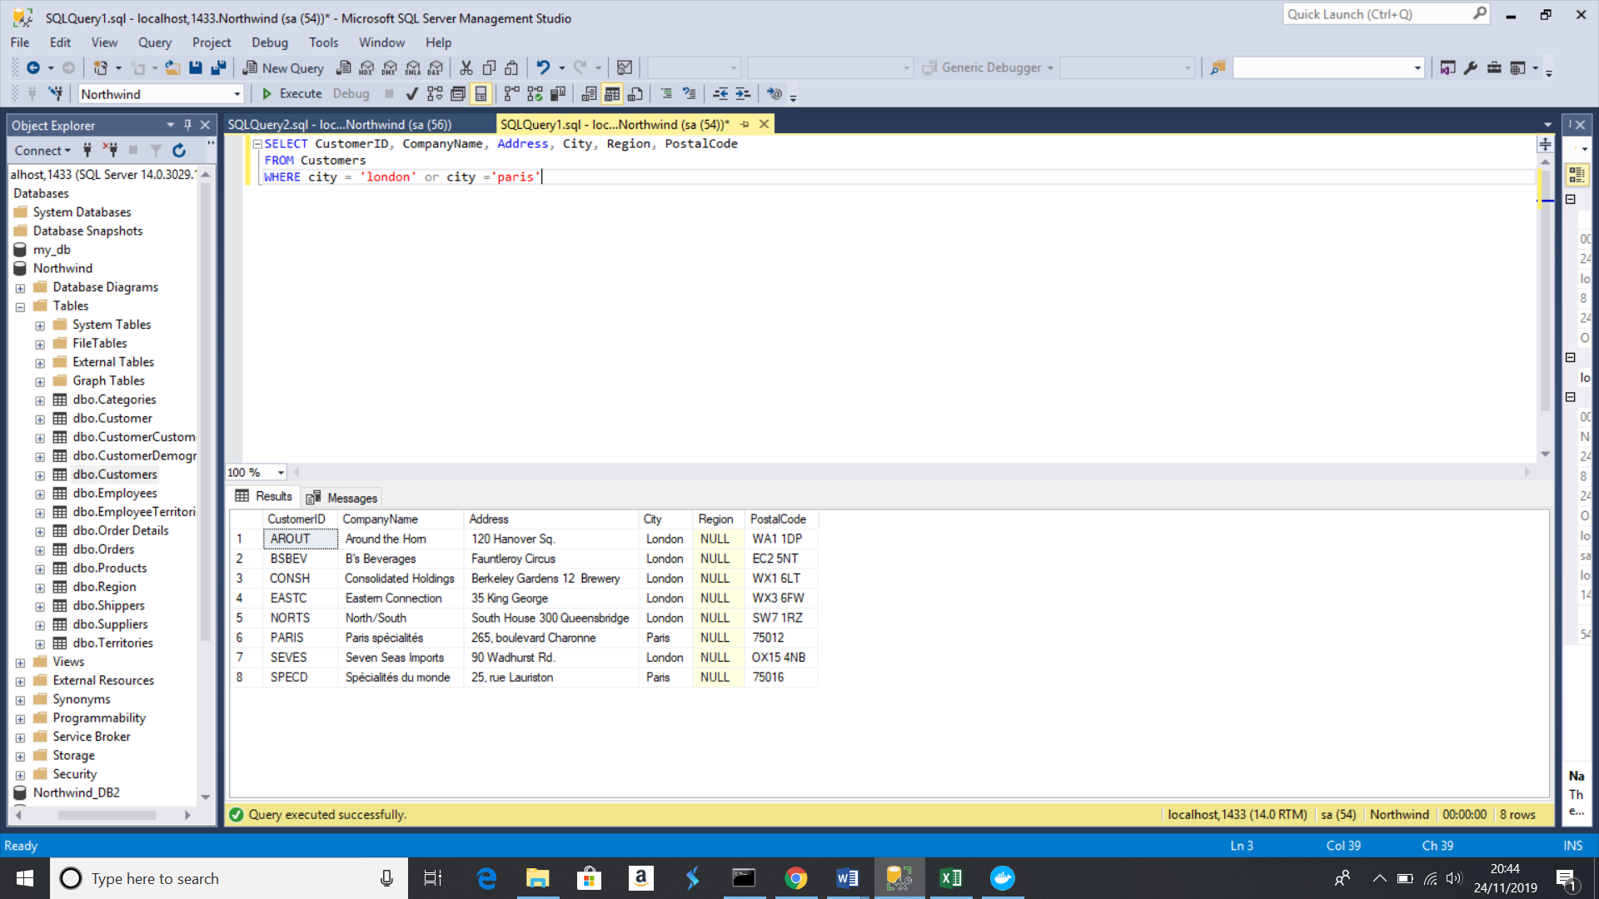

1. List all products stored in bottles

SELECT * FROM Products

WHERE QuantityPerUnit LIKE '%bottles'

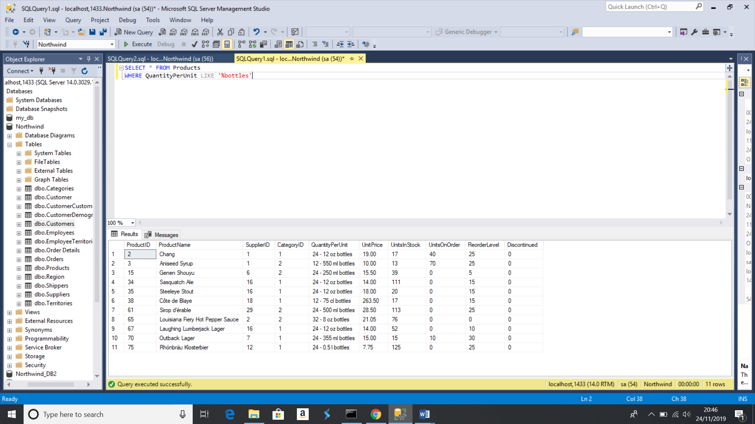

1. Repeat question above, but add in the Supplier Name and Country.

SELECT Products.*, Suppliers.CompanyName, Suppliers.Country

FROM Products

LEFT JOIN Suppliers ON Products.SupplierID=Suppliers.SupplierID

WHERE QuantityPerUnit LIKE '%bottles';

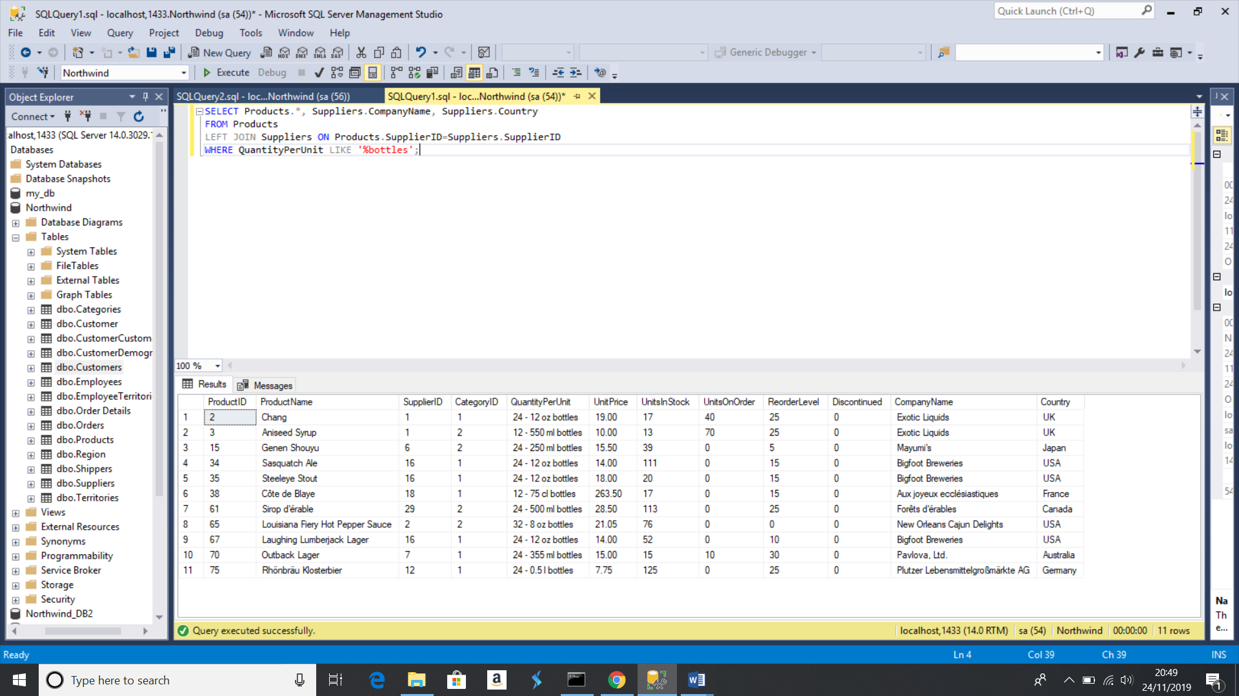

1. Write an SQL Statement that shows how many products there are in each category. Include Category Name in result set and list the highest number first.

SELECT count(Categories.CategoryID) 'Count', Categories.CategoryName

FROM Categories

LEFT JOIN Products ON Products.CategoryID=Categories.CategoryID

GROUP BY CategoryName

ORDER BY Count DESC;

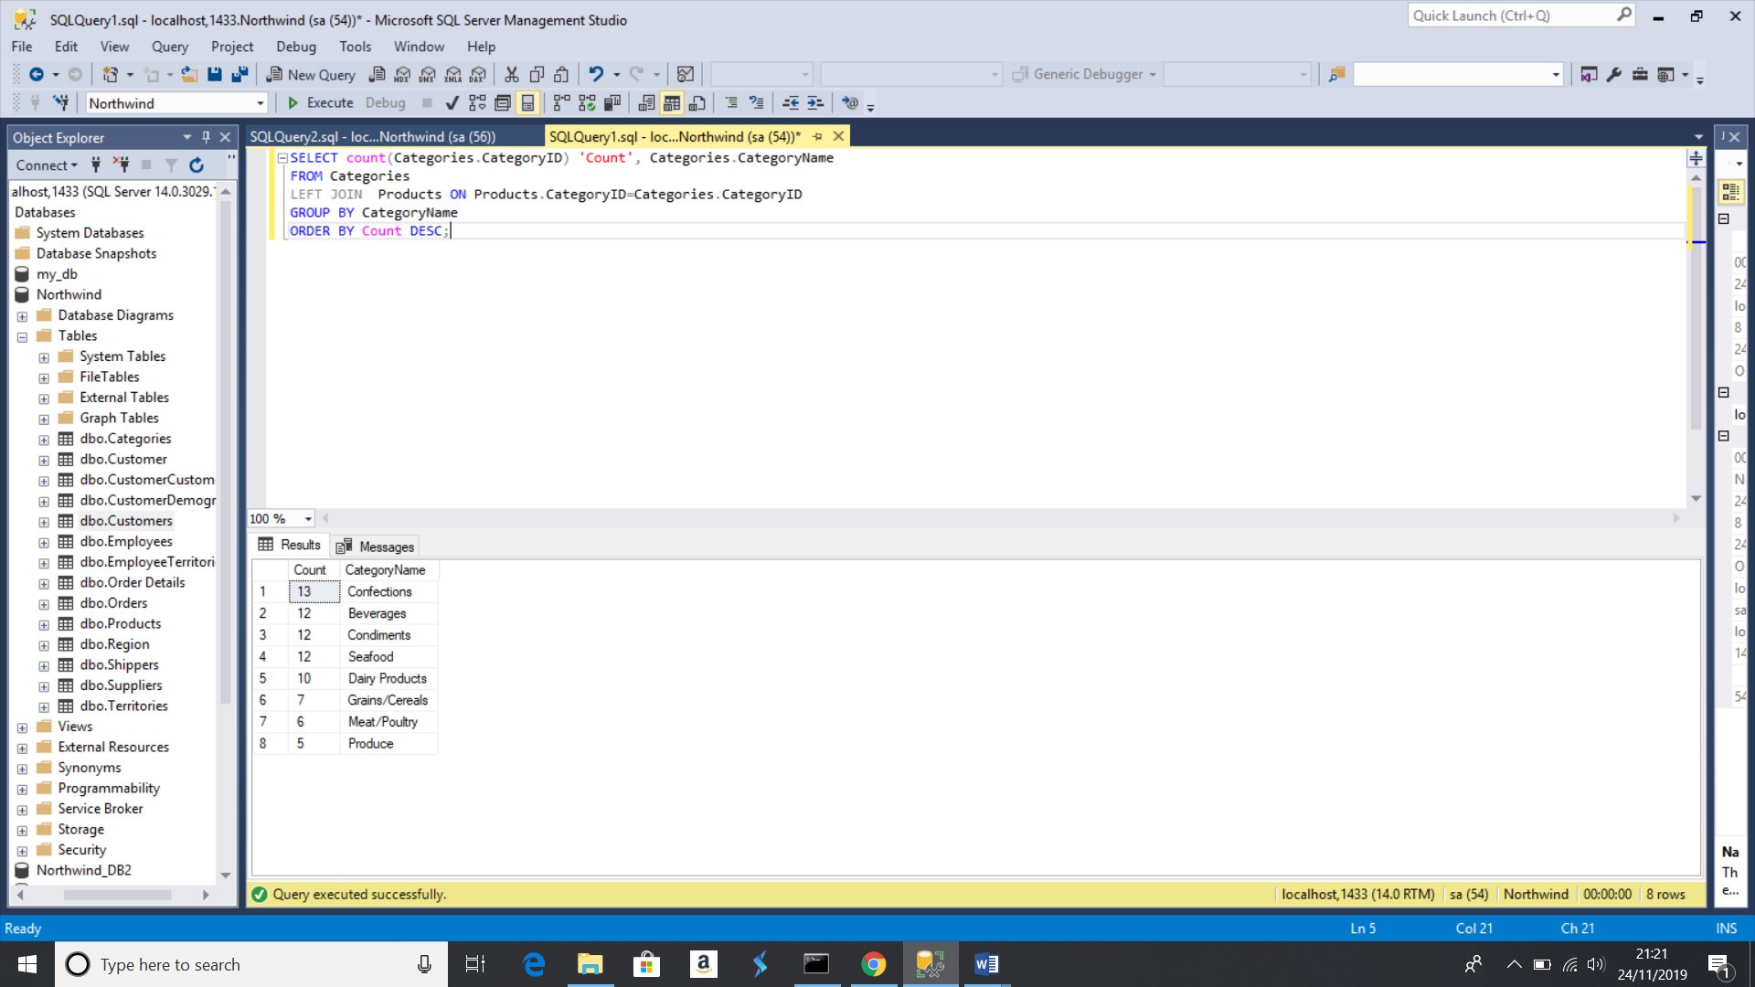

1. List all UK employees using concatenation to join their title of courtesy, first name and last name together. Also include their city of residence.

SELECT TitleOfCourtesy + ' ' + FirstName + ' ' + LastName

FROM Employees

WHERE Country = 'UK';

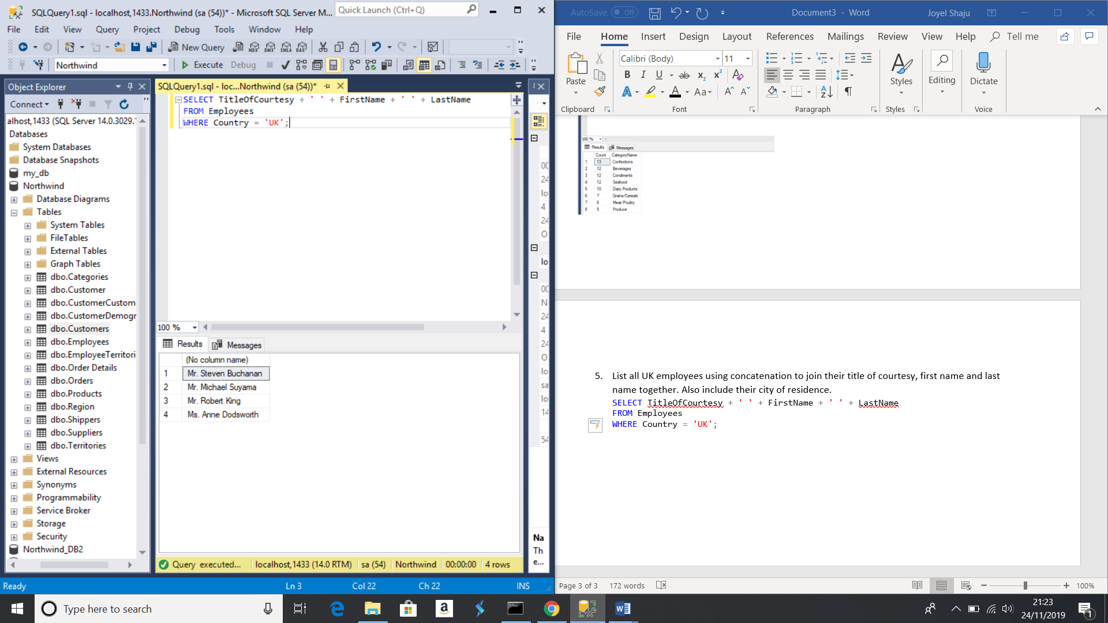

1. List Sales Totals for all Sales Regions (via the Territories table using 4 joins) with a Sales Total greater than 1,000,000. Use rounding or FORMAT to present the numbers.

USE Northwind

SELECT R.RegionDescription,

CAST(SUM(ROUND((OD.UnitPrice * OD.Quantity)-(OD.UnitPrice * OD.Quantity * OD.Discount) + O.Freight, 2)) AS MONEY) AS Total_Sales

FROM Territories T

JOIN Region R

ON T.RegionID = R.RegionID

JOIN EmployeeTerritories ET

ON T.TerritoryID = ET.TerritoryID

JOIN Orders O

ON ET.EmployeeID = O.EmployeeID

JOIN [Order Details] OD

ON O.OrderID = OD.OrderID

GROUP BY R.RegionDescription

HAVING CAST(SUM(ROUND((OD.UnitPrice * OD.Quantity)-(OD.UnitPrice * OD.Quantity * OD.Discount) + O.Freight, 2)) AS MONEY) >1000000

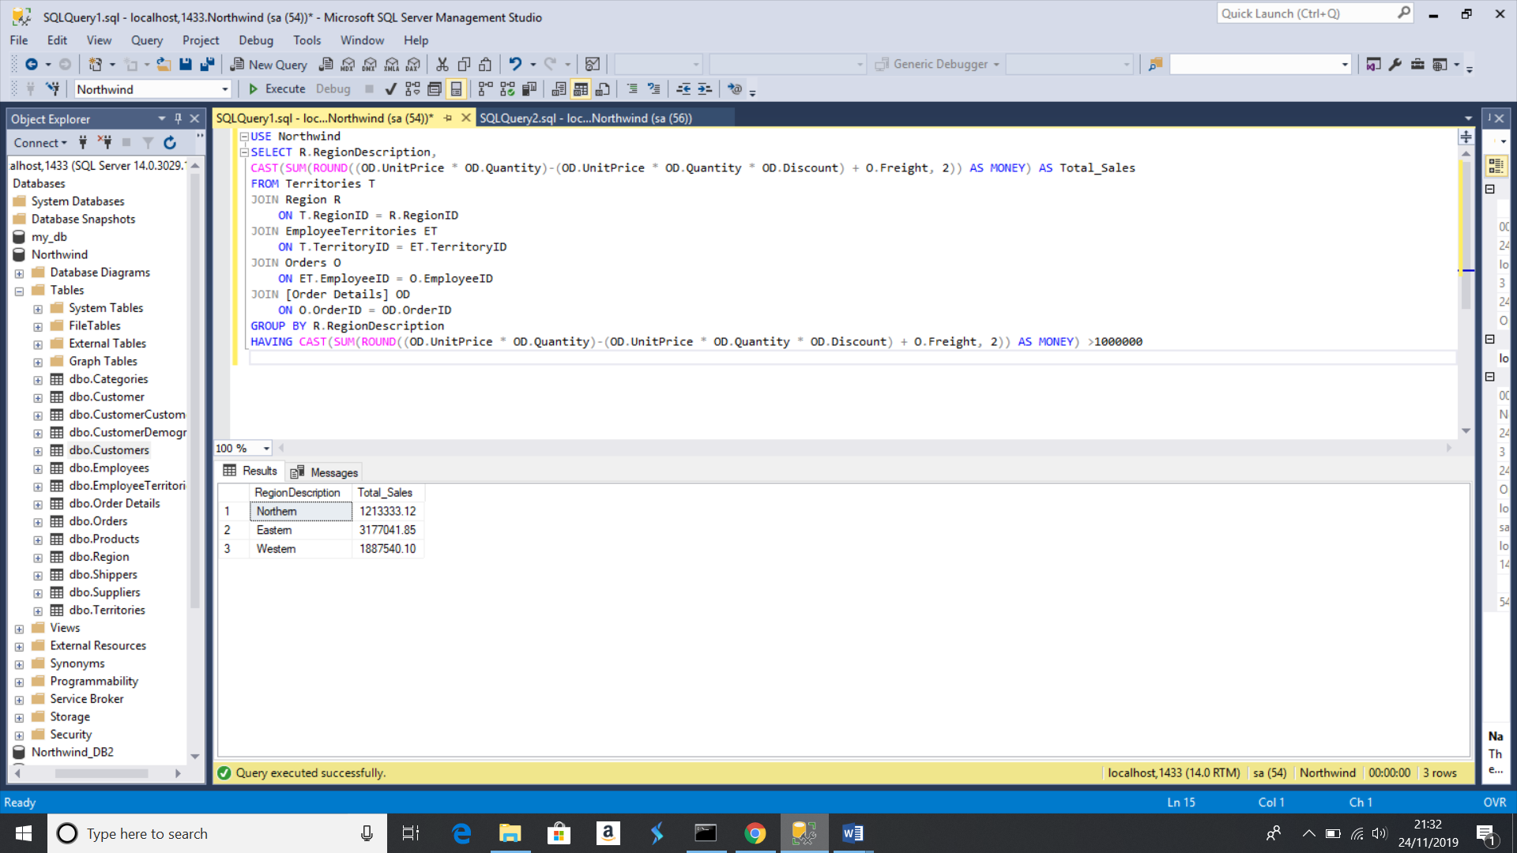

1. Count how many Orders have a Freight amount greater than 100.00 and either USA or UK as Ship Country

SELECT COUNT(Freight)

AS Freight_greater_100

FROM orders

WHERE Freight > 100 AND (ShipCountry = 'USA' OR ShipCountry = 'UK')

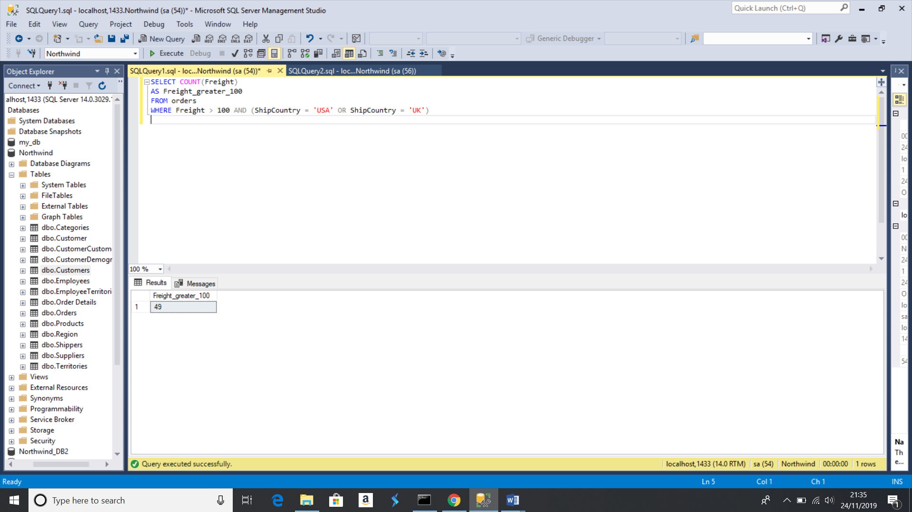

1. Write an SQL Statement to identify the Order Number of the Order with the highest amount of discount applied to that order.

SELECT TOP 1 [Order Details].OrderID, ROUND(sum(Unitprice*Quantity),2) AS TotalPrice, ROUND(sum((UnitPrice*Quantity)*Discount),2) AS Deducted

FROM [Order Details]

GROUP BY OrderID

ORDER BY Deducted DESC;

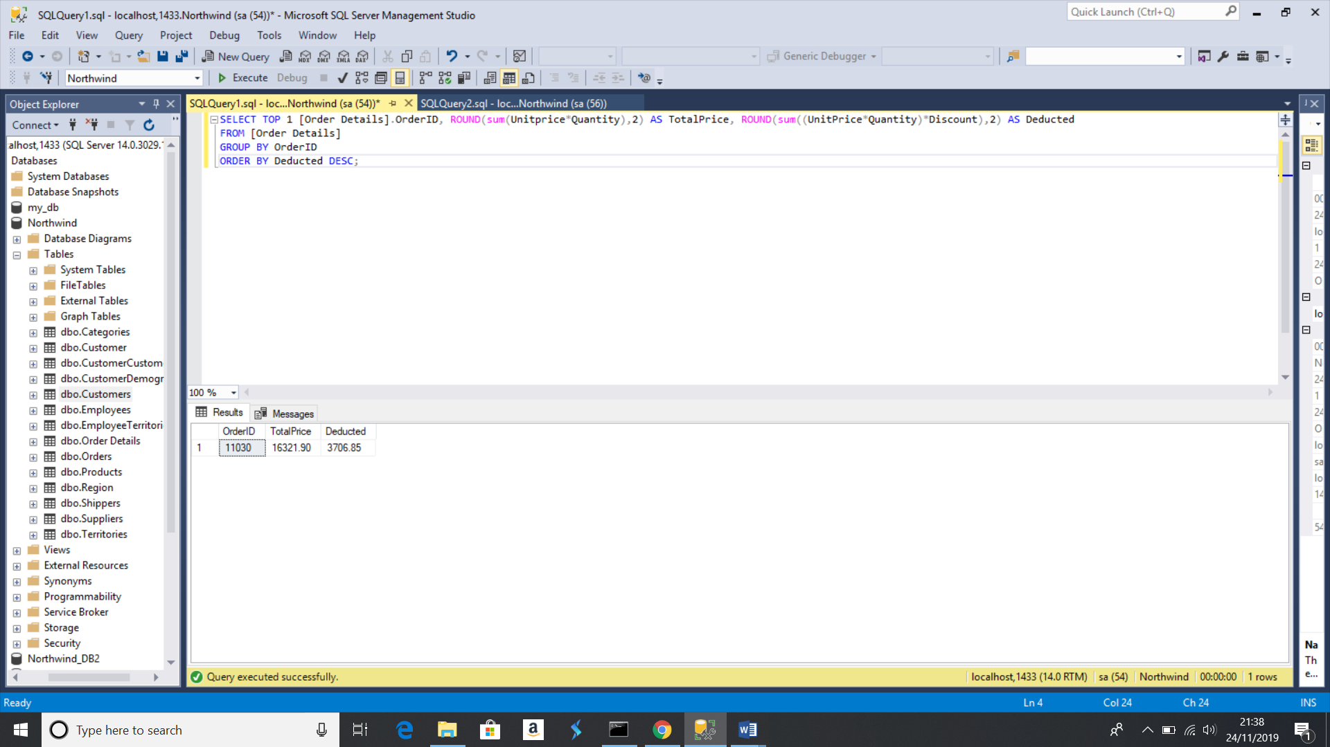

Exercise 2 – Create Spartans Table

2.1

CREATE TABLE Spartans_info(

Spartan_id int PRIMARY KEY IDENTITY(1,1),

Separate_title varchar(8),

First_name varchar(60),

Last_name varchar(60),

University varchar(60),

Course varchar(60),

Grade varchar(10),

);

2.2

INSERT INTO Spartans_info  
(  
Separate_title, First_name, Last_name, University, Course, Grade  
)  
VALUES  
('Mr','Shaqil','Abdullah','Brunel','Mechanical Engineering','2:1'),  
('Mr','Zaid','Iqbal','Queen Mary','Computer Science','2:1'),  
('Mr','Joyel','Shaju','Coventry','Computer Science','1:1'),  
('Mr','Victor','Granados Jimenez','Granada','Information and Documentation','2:1'),  
('Mr','Jack','Farmer','Leeds','Physics','2:1'),  
('Mr','Mohammad','Khwaja','Westminster','Electronic Engineer','2:2'),  
('Mr','Thomas','Briggs','Bournemouth','Exercise Science','1:1'),  
('Mr','Daniel','Lippross','Hull','Chemistry','2:2'),  
('Mr','Paul','Brewer','Hull','Computer Science','1:1'),  
('Miss','Elizabeth','Nicholl','Cantebury Christ Church University','Sport and Exercise','1:1'),  
('Miss','Ariadna','Gonzalez Lopez','London Metropolitan','Business Information Technology','1:1'),  
('LORD','Ygor','Teixeira','University of Greenwhich','Games Design and Development','2:2'),  
('Mr','Anjum Ali','Saiyad','Queen Mary','Mathematics','2:2'),  
('Mr','Hussain','Fiaz','University of East London','Computer Science','2:2');

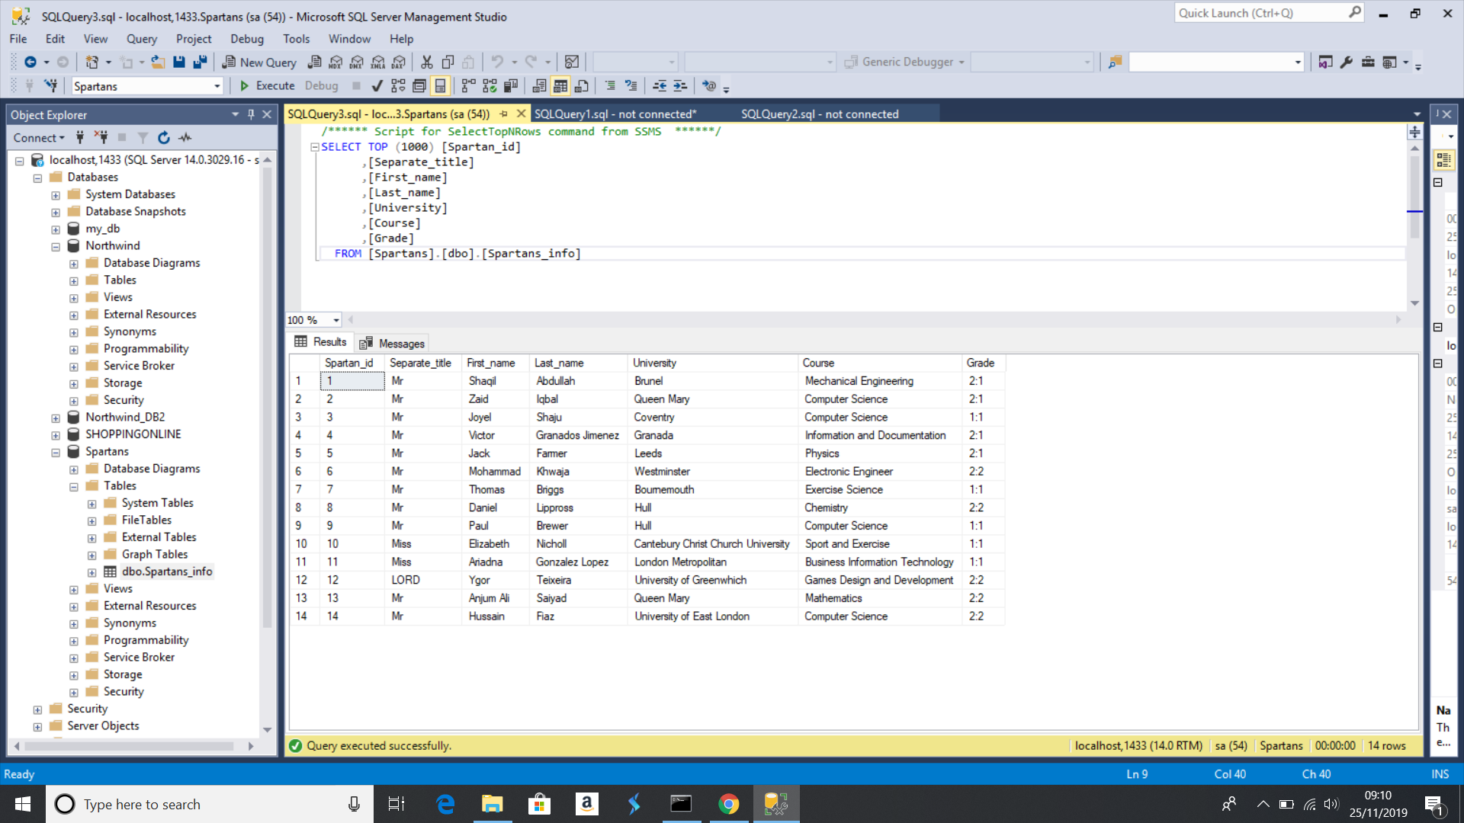

Exercise 3 – Northwind Data Analysis linked to Excel

3.1

SELECT Employees1.FirstName, Employees1.LastName, Employees2.FirstName, Employees2.LastName

FROM Employees AS Employees1

LEFT JOIN Employees AS Employees2

ON Employees1.ReportsTo = Employees2.EmployeeID;

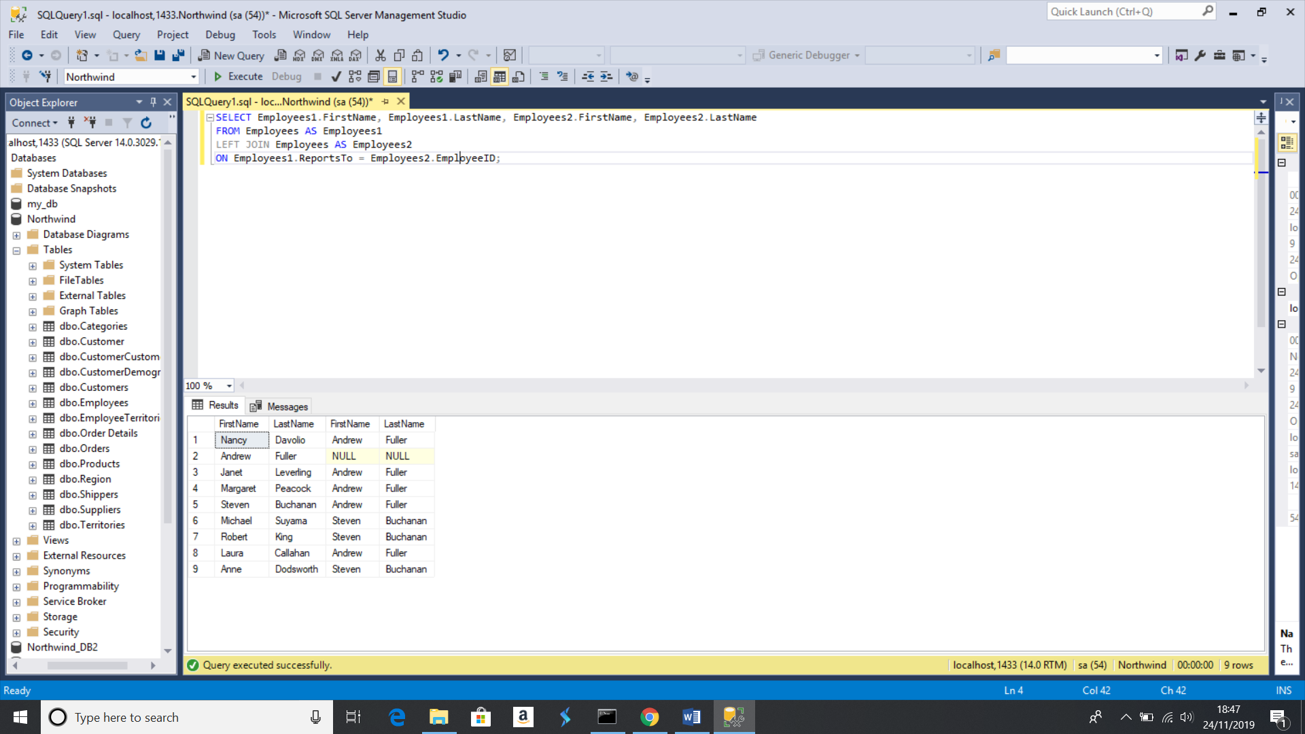

3.2

SELECT Suppliers.CompanyName, ROUND(SUM([Order Details].UnitPrice * (1 - Discount)* Quantity),2) AS TotalSales

FROM [Order Details]

JOIN Products ON [Order Details].ProductID = Products.ProductID

JOIN Suppliers ON Products.SupplierID = Suppliers.SupplierID

GROUP BY Suppliers.CompanyName

HAVING ROUND(SUM([Order Details].UnitPrice * (1 - Discount) * Quantity),2) > 10000;

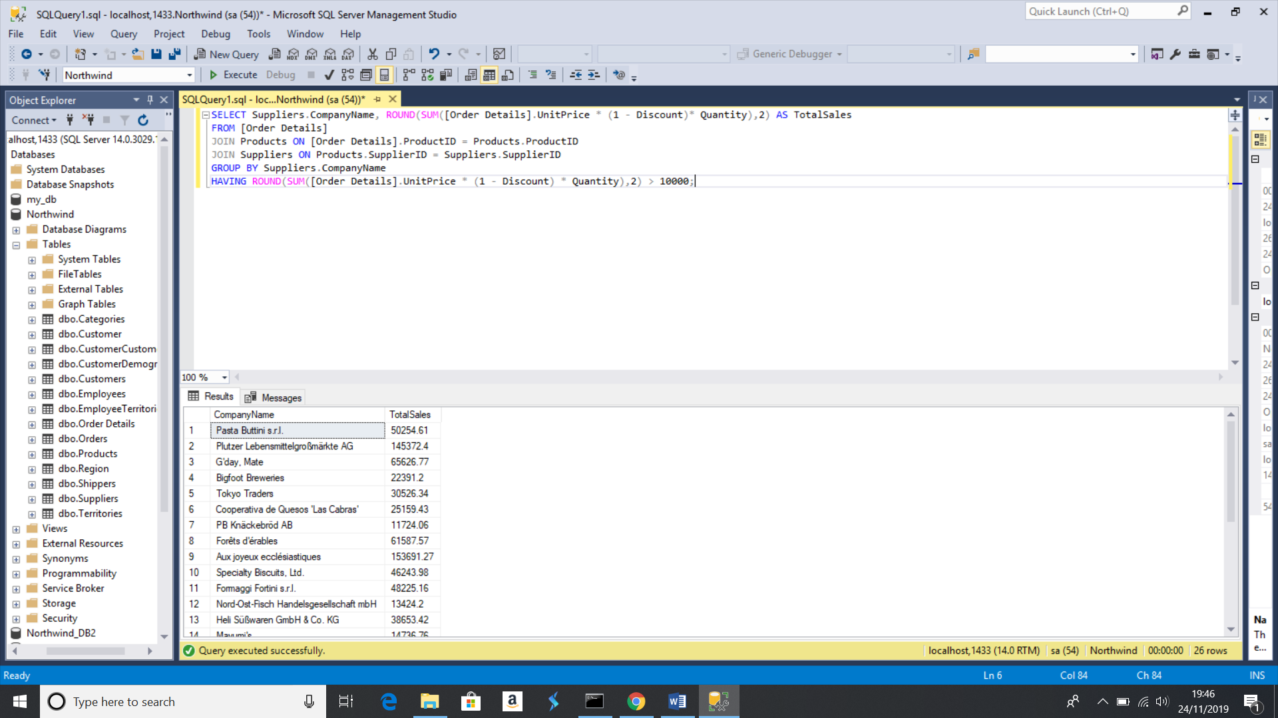

3.3

-- Selects top 10 customers for the year 1998

SELECT TOP 10

CustomerID AS "Customer",

SUM(UnitPrice * Quantity * (1 - Discount)) AS "Total Sales"

FROM Orders O

JOIN [Order Details] OD

ON O.OrderID = OD.OrderID

GROUP BY CustomerID, OrderDate

HAVING YEAR(OrderDate) = 1998

ORDER BY "Total Sales" DESC;

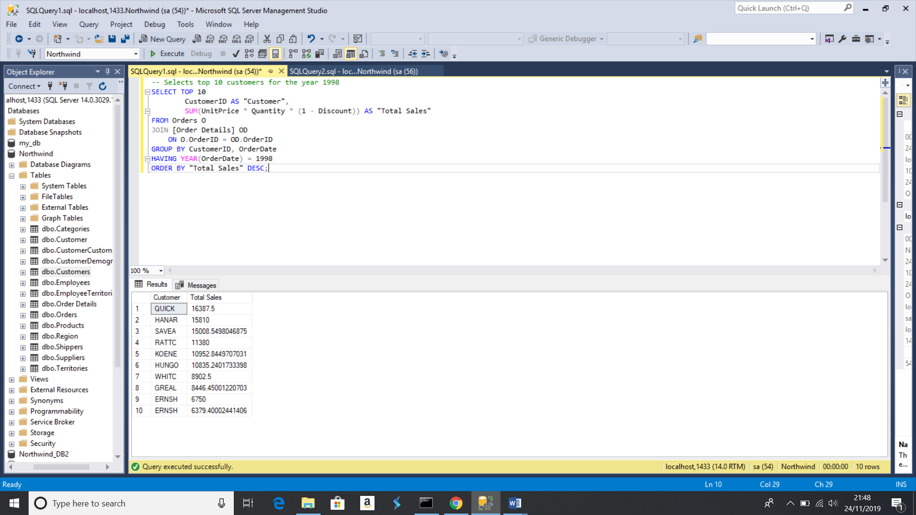

3.4

SELECT CONCAT(MONTH(OrderDate), '-', YEAR(OrderDate)) 'Order date', AVG(DATEDIFF(DAY, OrderDate, ShippedDate)) 'Avg shipping time'

FROM Orders

GROUP BY CONCAT(MONTH(OrderDate), '-', YEAR(OrderDate));

